url: <http://localhost:4200/login>

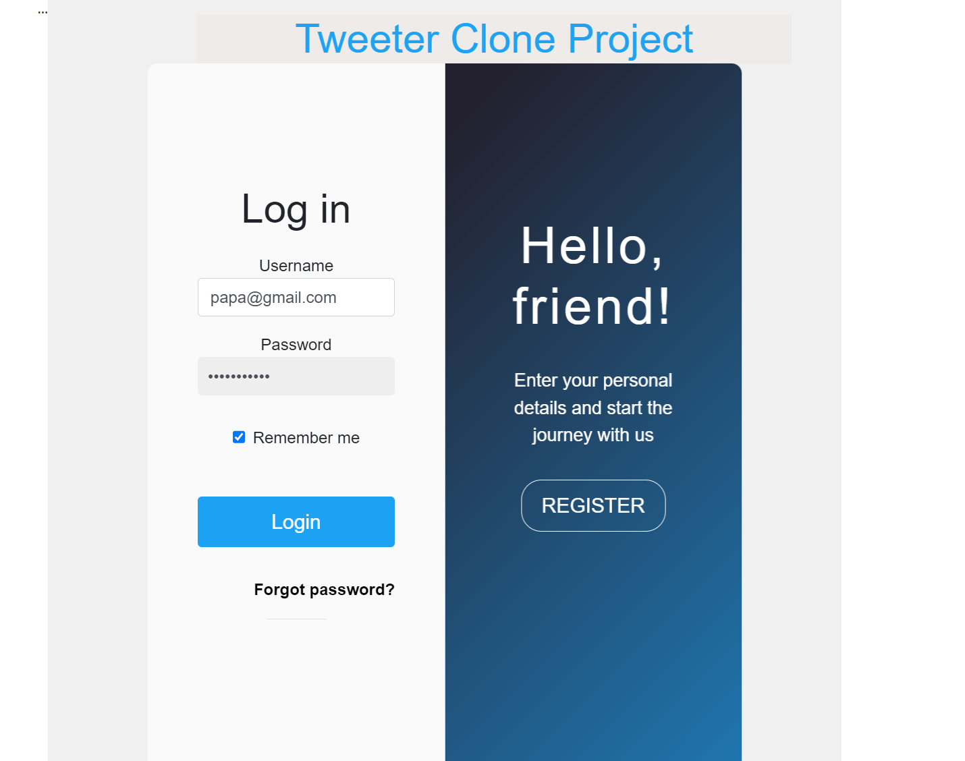

Here, I've implemented an animation to enhance the page appearance, integrated the "Remember Me" and "Forgot Password" functionalities, and included robust validation for the username and password fields. The system makes API calls and appropriately displays success or failure responses. For a quick overview, you can observe the login page view in the clip below.



Upon successful authentication, we can see the alert

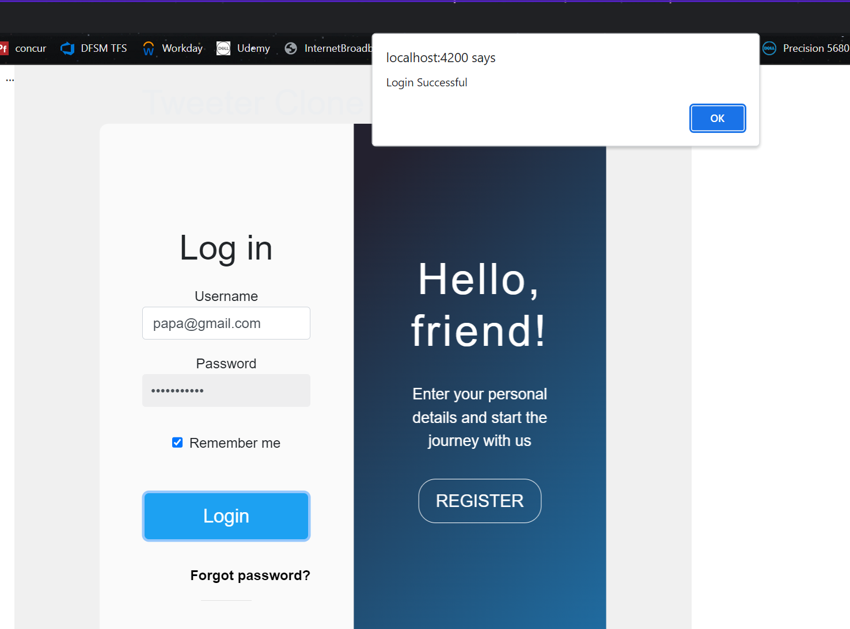

For my understanding, I am showing the token which we are getting from the API call

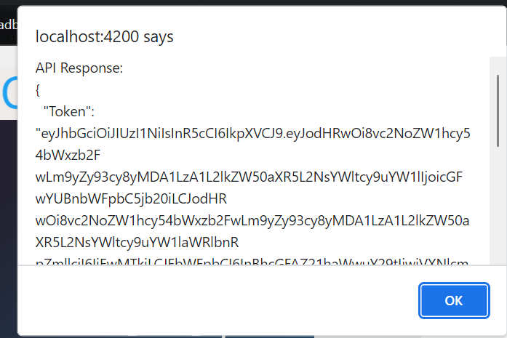

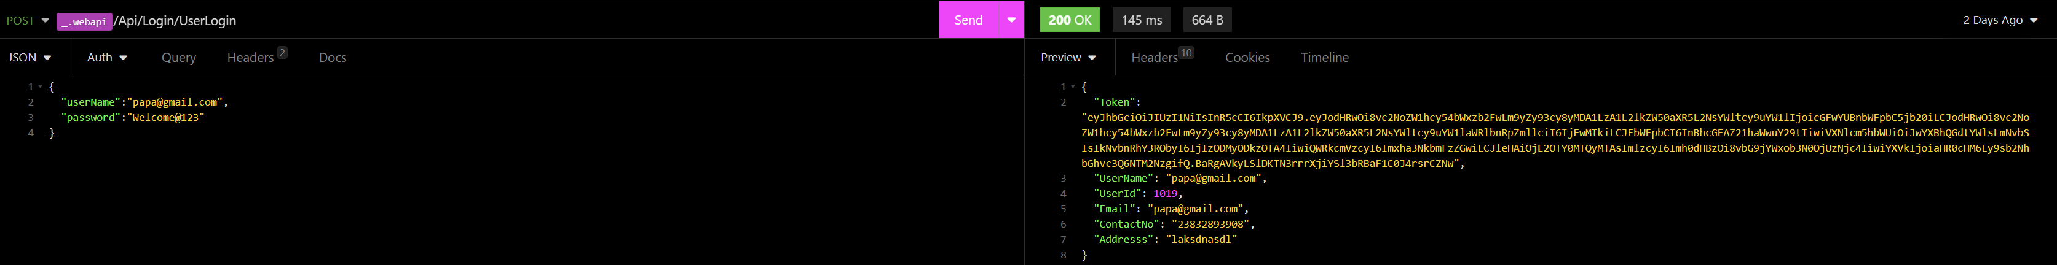

So I have succesfuuly integrated the api which is working to authenticate user

Below are other validation it compasses:

When you enter blank username or password

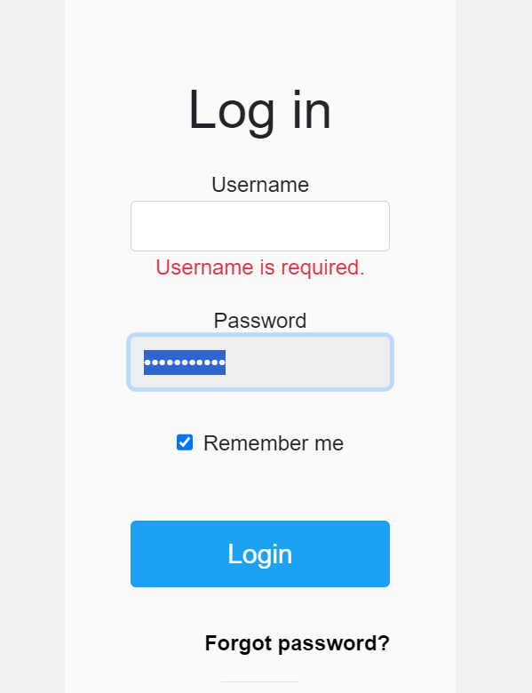

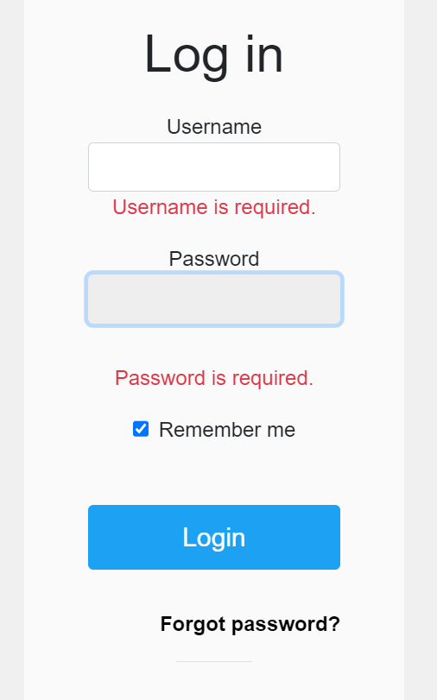

Entering incorrect password with valid username

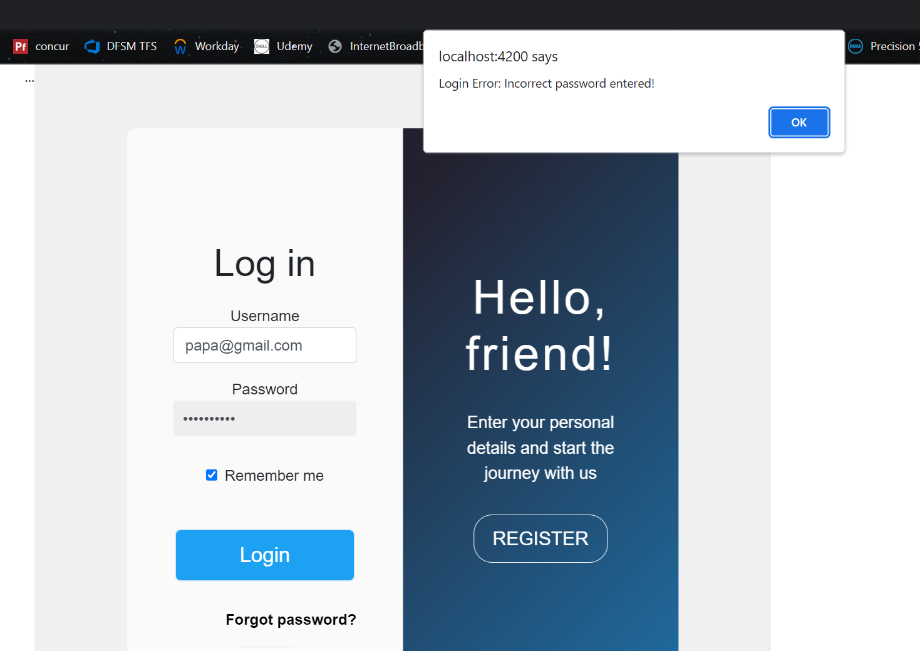

Entering incorrect username with correct password

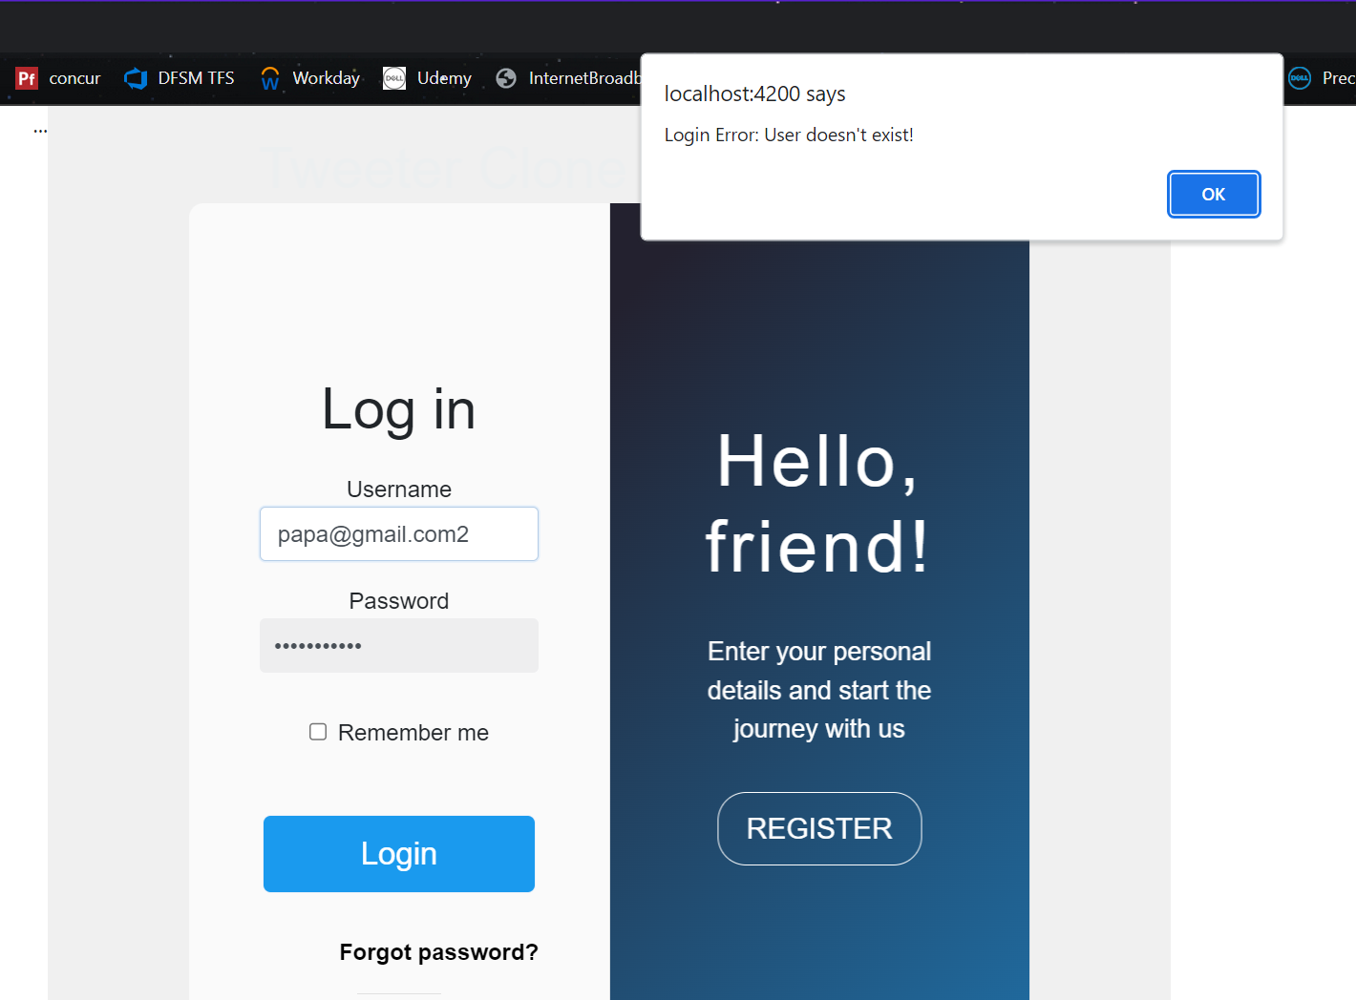

API picture: 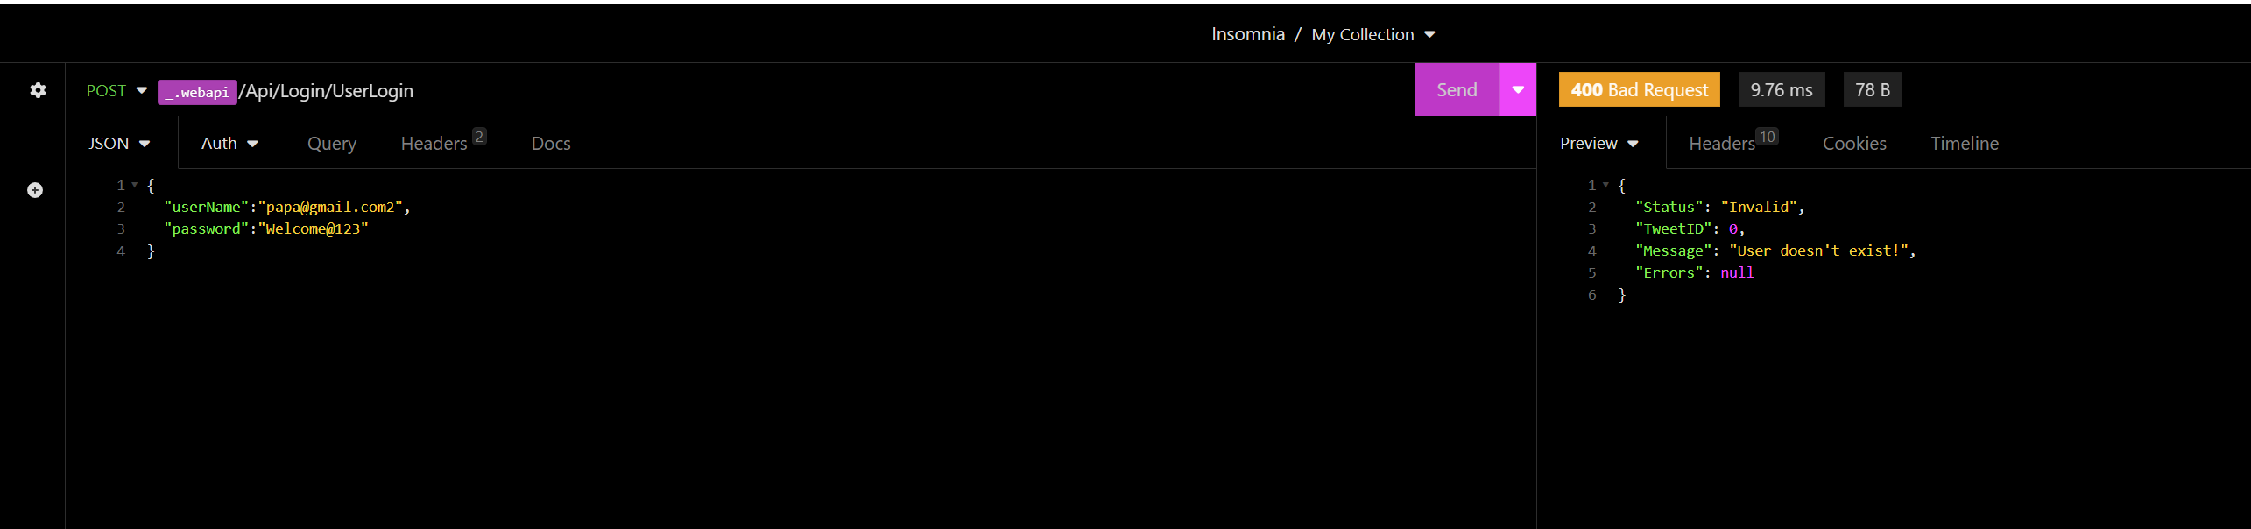

Registration page:

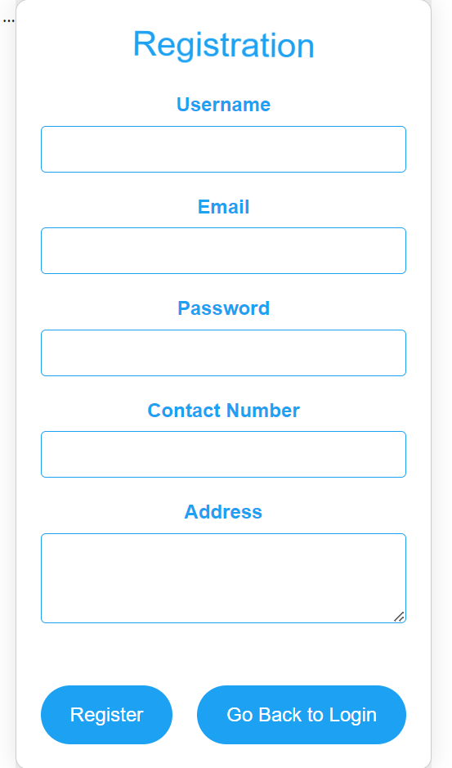

Successfully achieved all the validations on each field and on any empty fields, accordingly pop up will be shows after the API is hit, also have added animation on heading which spins on top

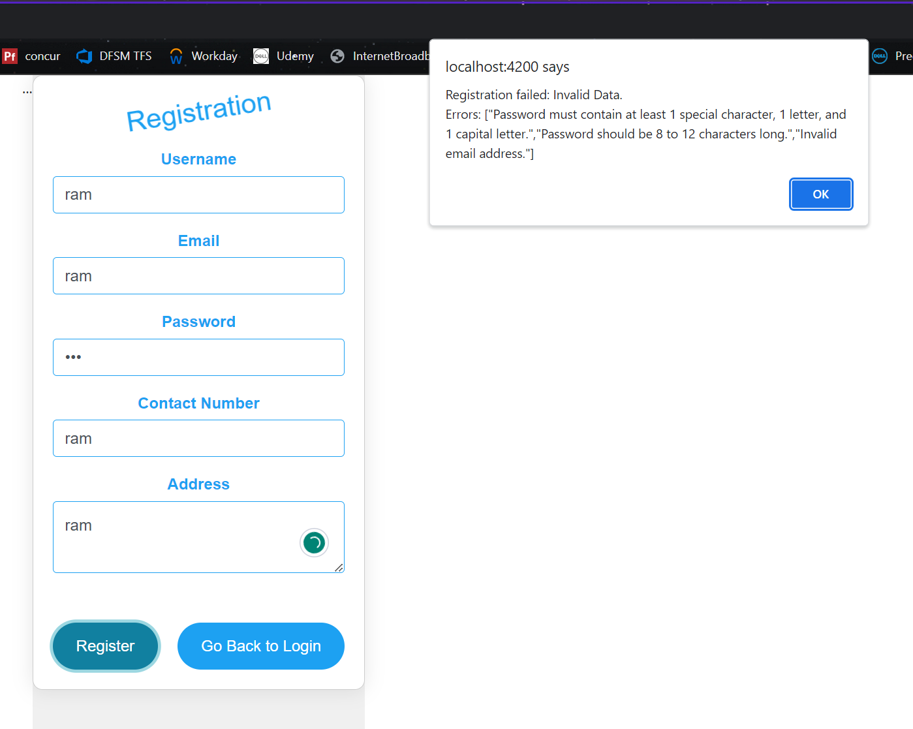

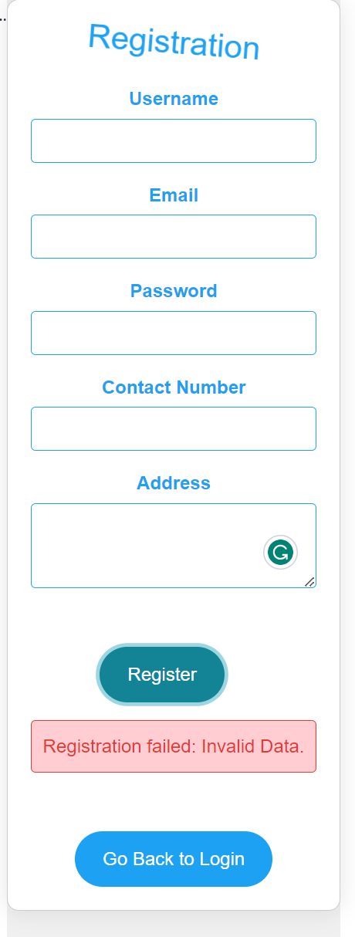

Registering already existing user , it prevents as expected

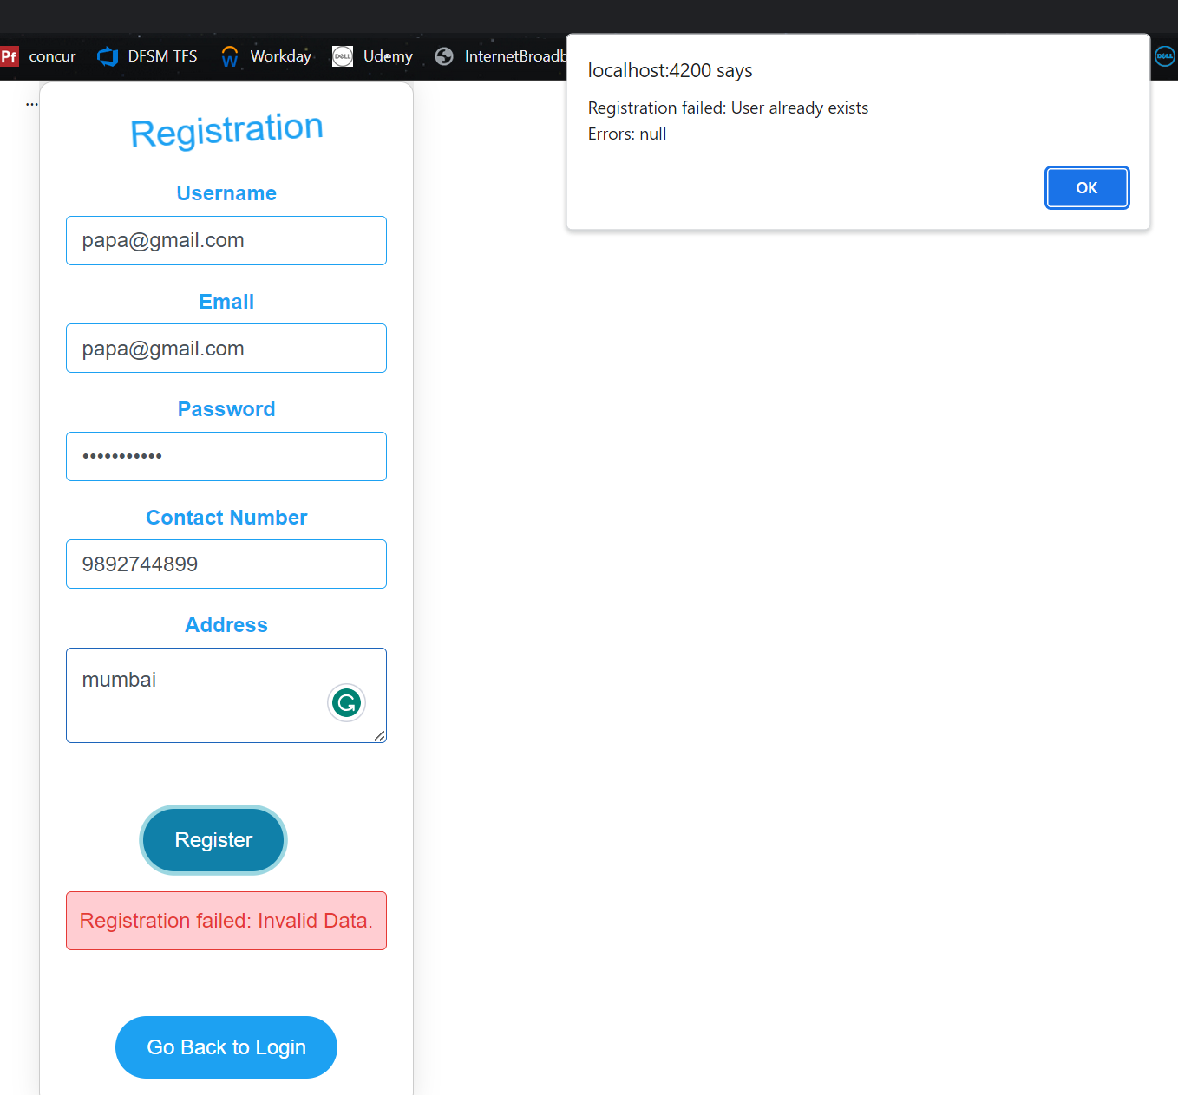

API response behind the scene

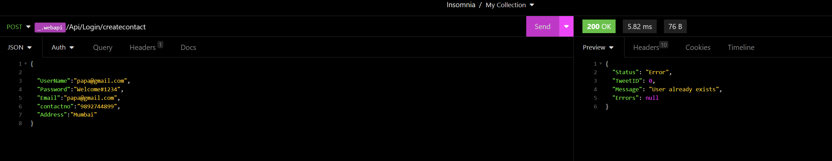

If I don’t fill all the required fields

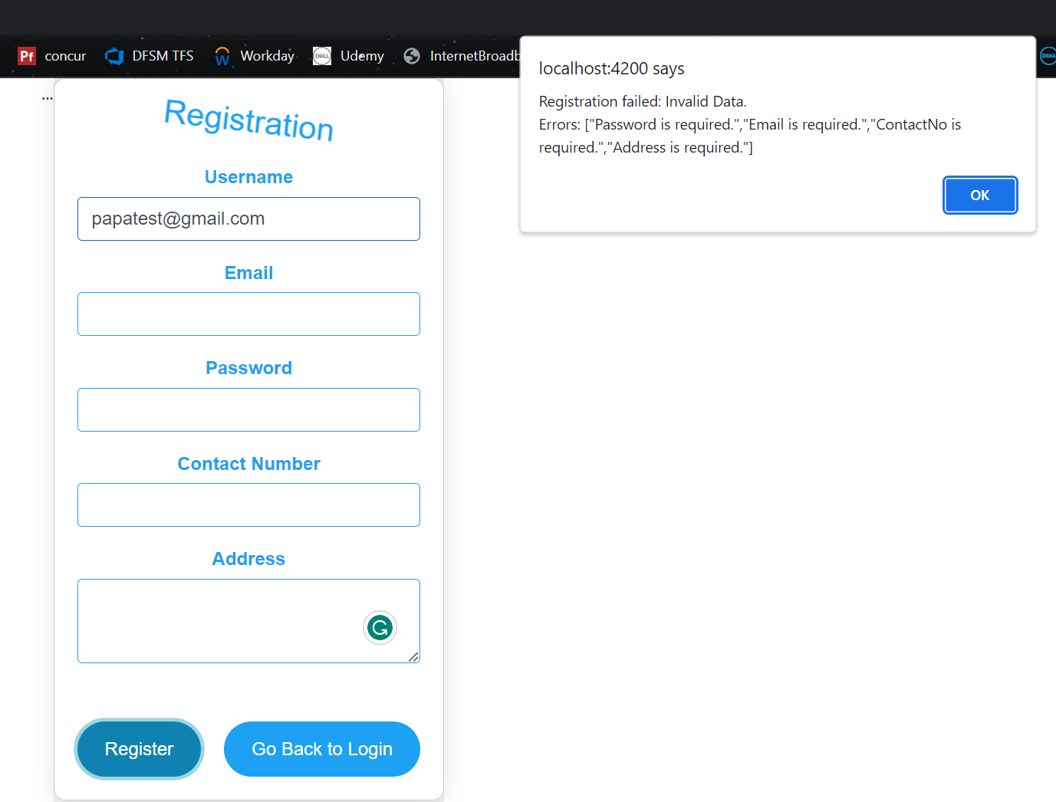

When all the validation passed

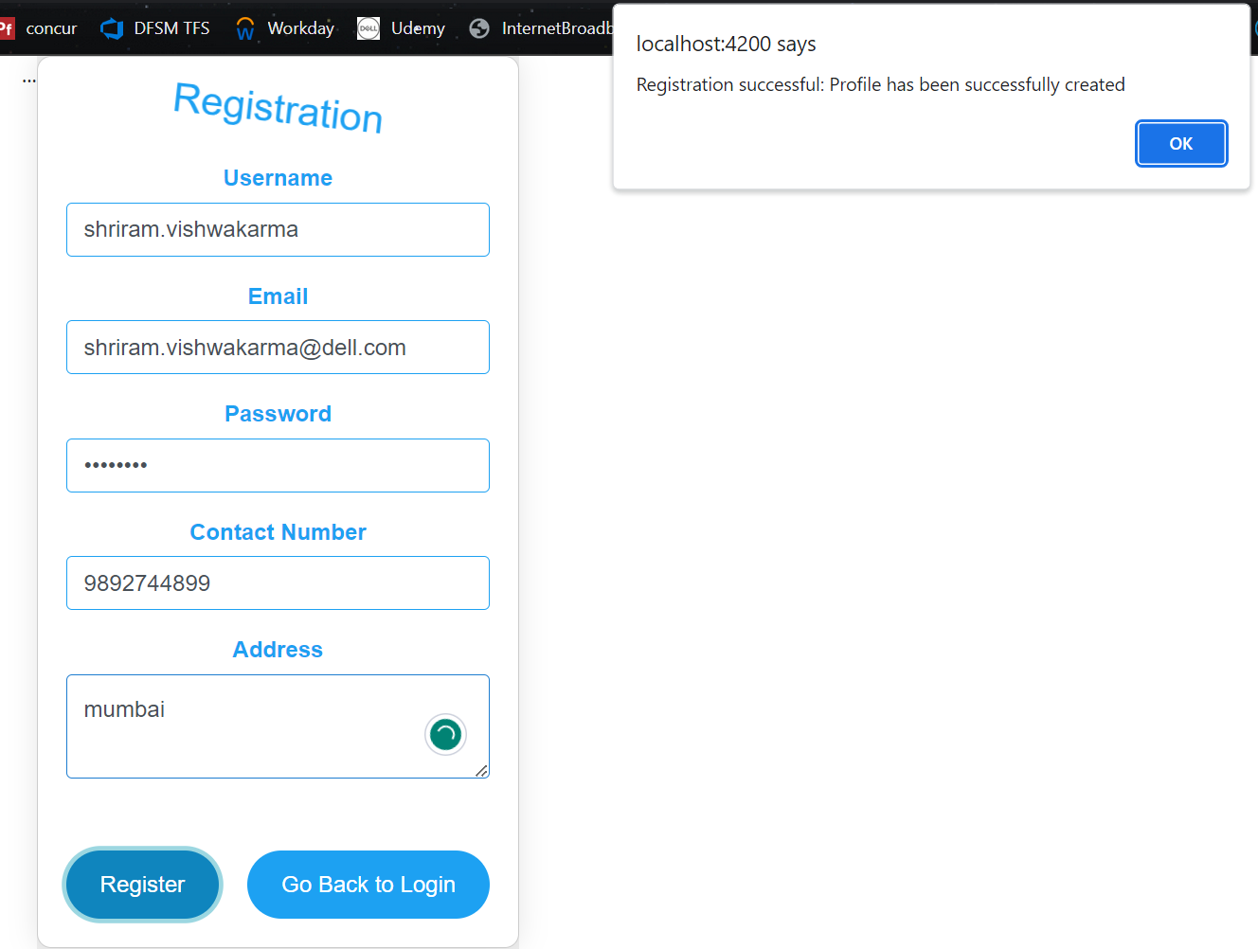

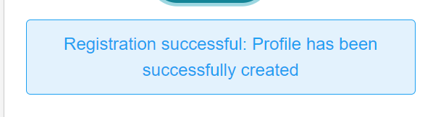

API response behind the scene

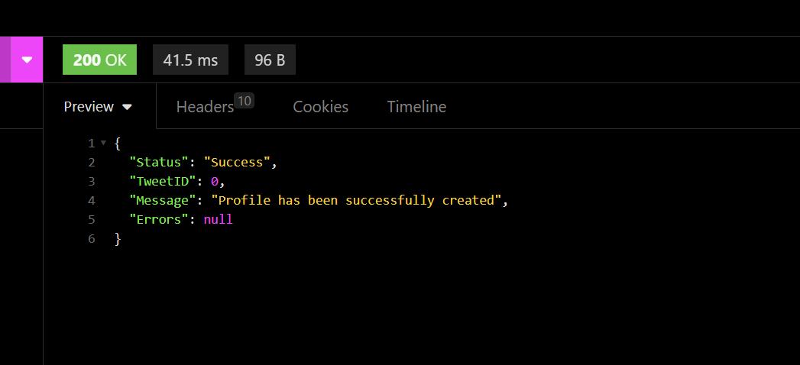

Lets log in with newly registered user

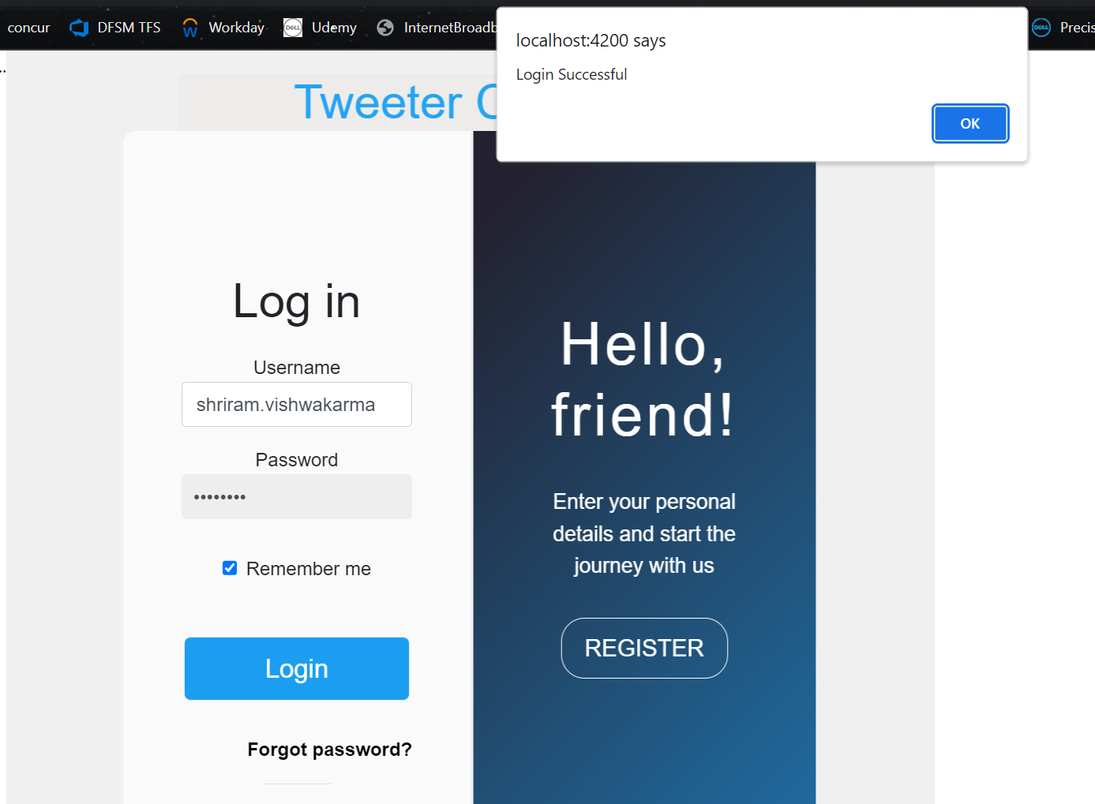

If you want to reset your password, hit forgot password from main login page and it will lead you to password reset page as shown below

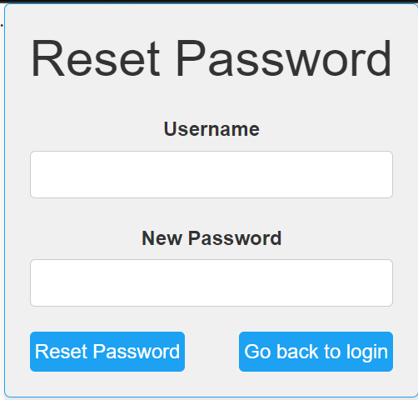

Adding some validation

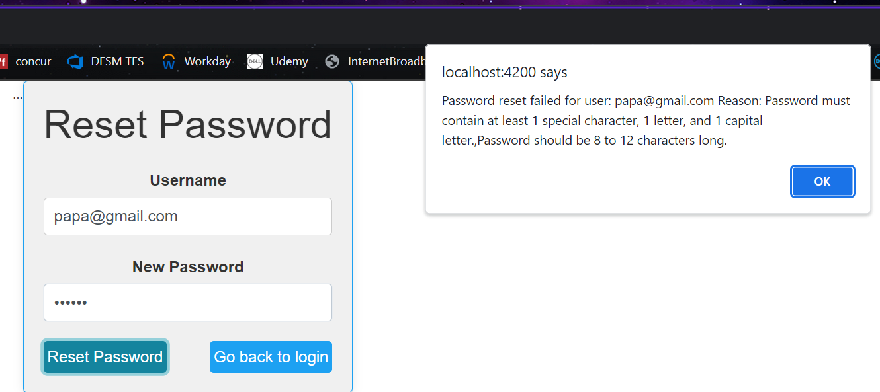

Hitting reset button without entering values

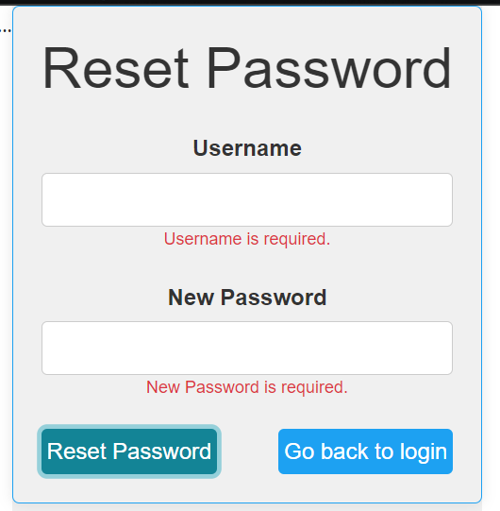

Keeping anyone field blank

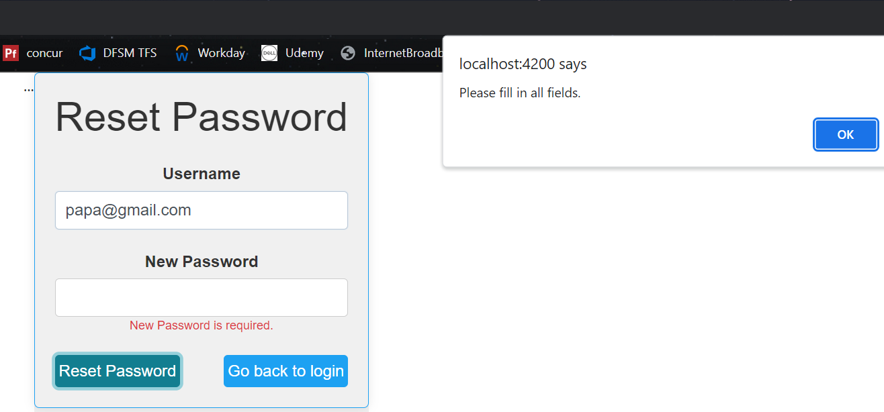

Successful password reset once all the validation passed,

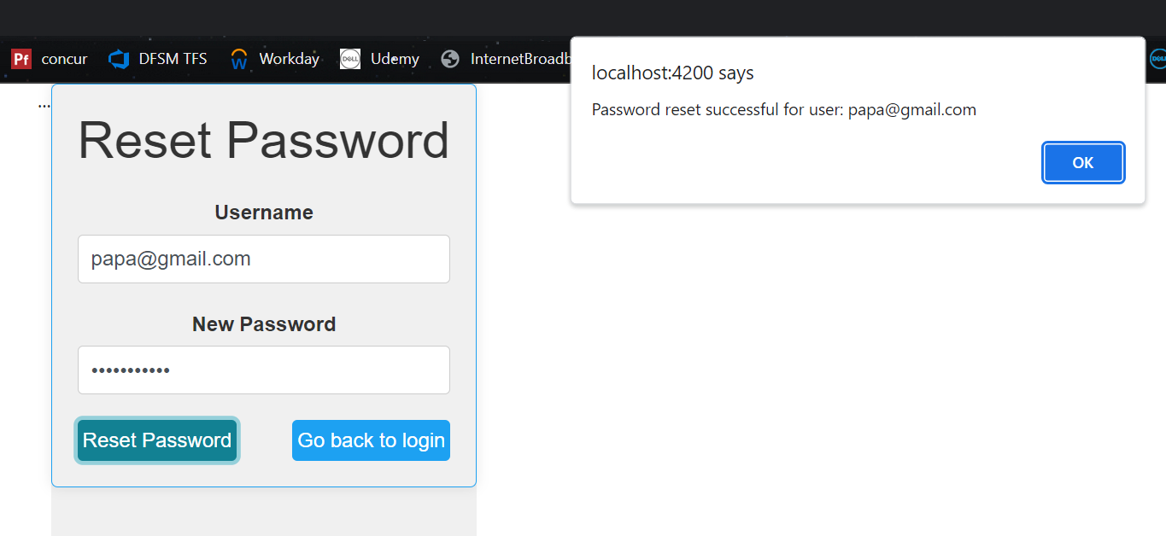

API response behind the scene:

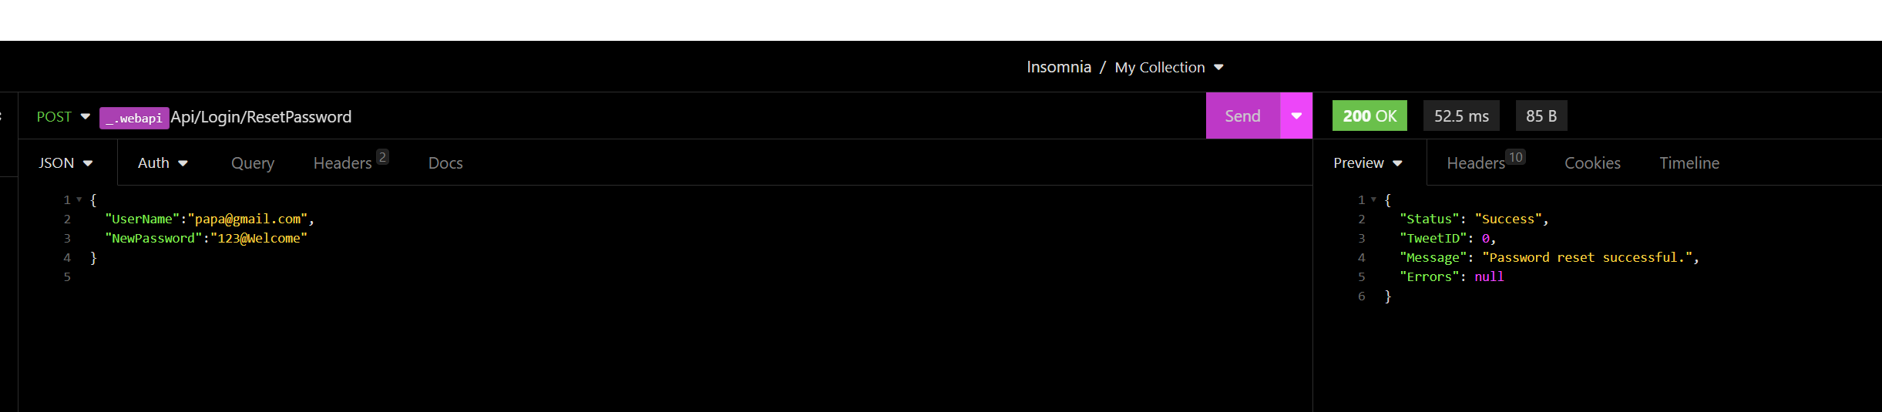

Once hit ok, auto leads to login page

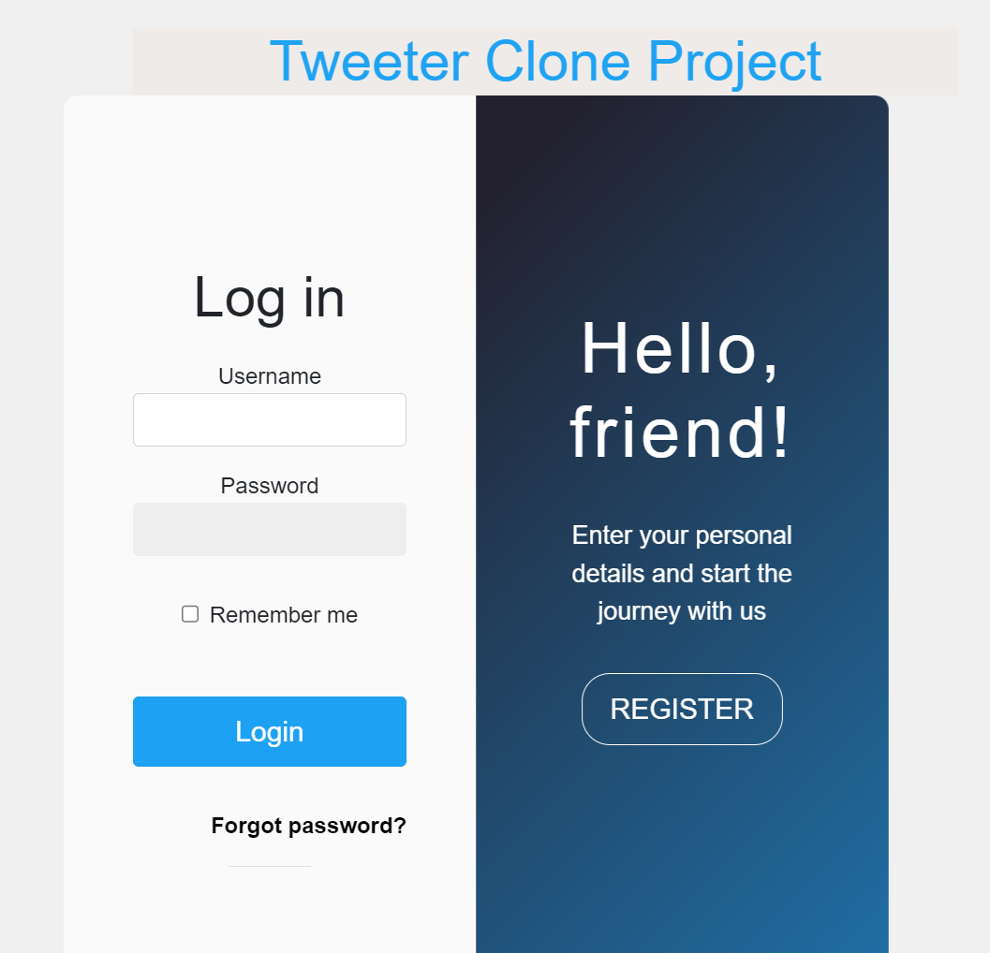

Once successful logged in, tweet feed will be loaded, and you can see the home page.

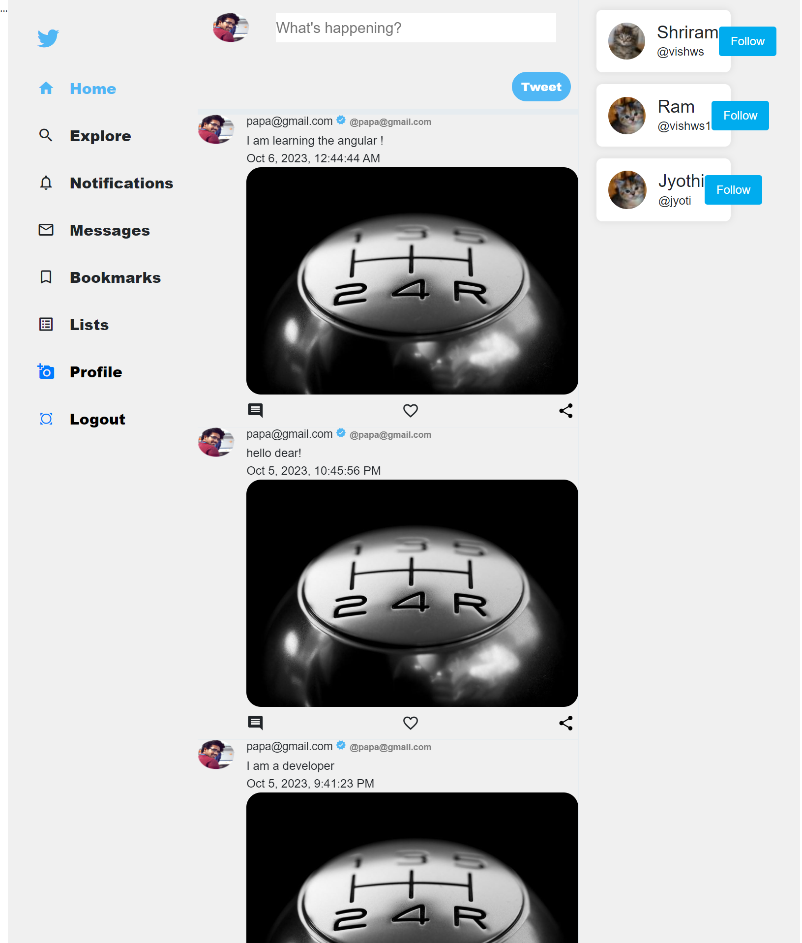

API response behind the scenes:

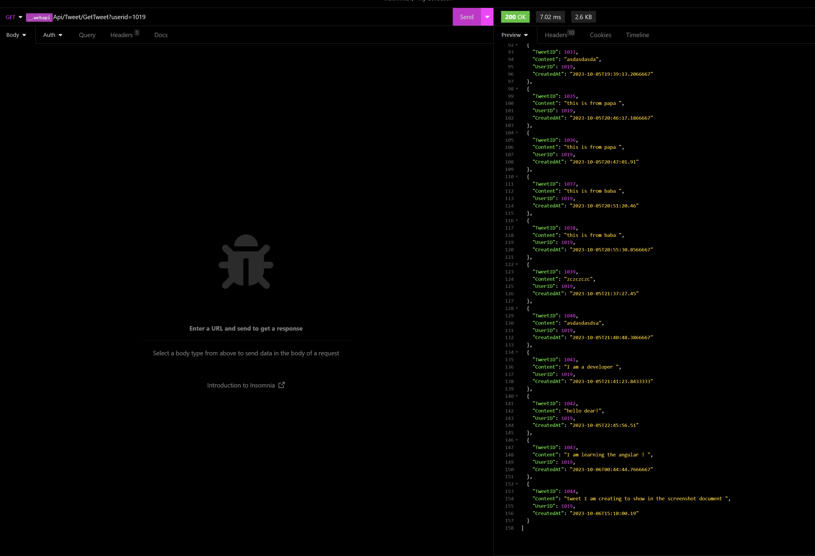

You should see the username has autofetched based on the token and userid stored in localdtorage and through API it has automatically fetched the username, its profilepicture etc

Once you create a tweet and hit tweet button, it will show the most recent tweet that you have just now created along with the datetime stamp

Like, I am creating a new tweet now, you can now see the page has now loaded newly created tweets and all the previous tweets will also be shown

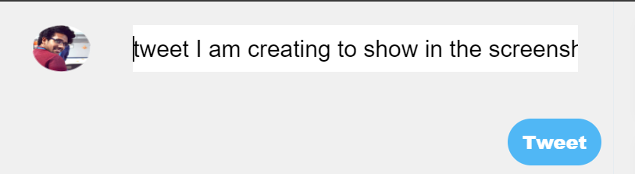

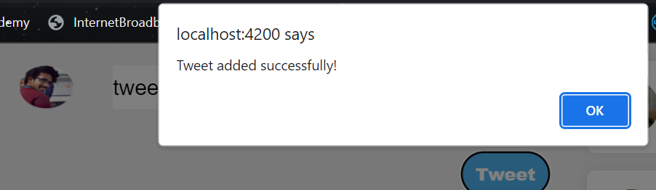

And when trying to tweet without any text

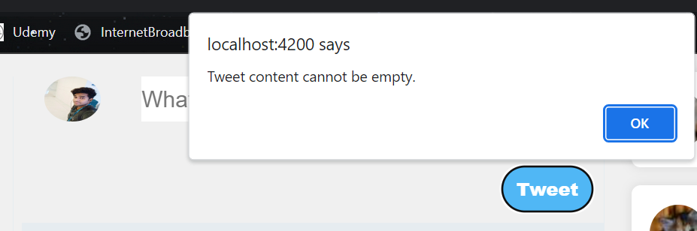

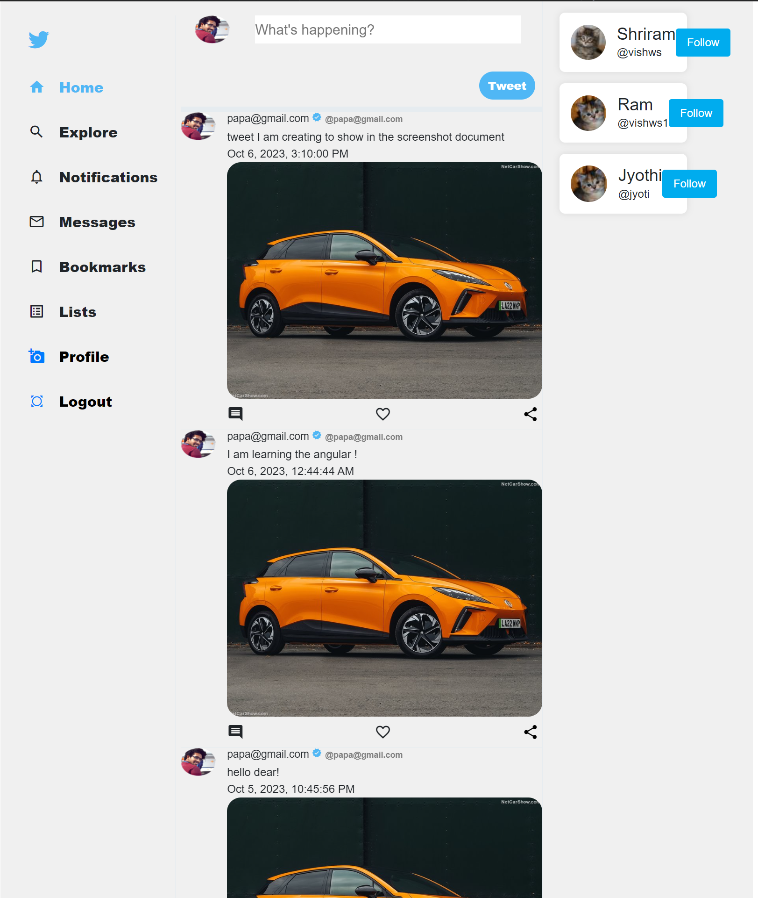

Once you hit the profile , you can change the profile details such as changing the bio, profile picture, resetting the password

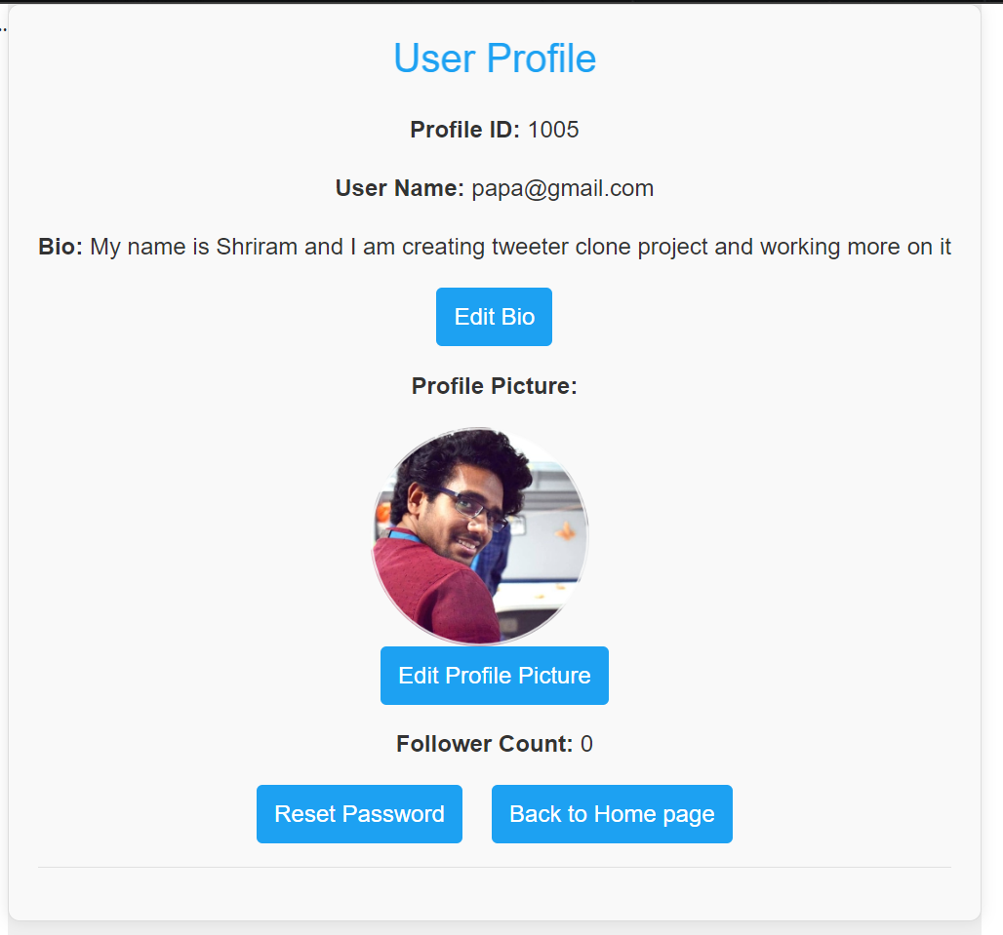

You can edit the details.

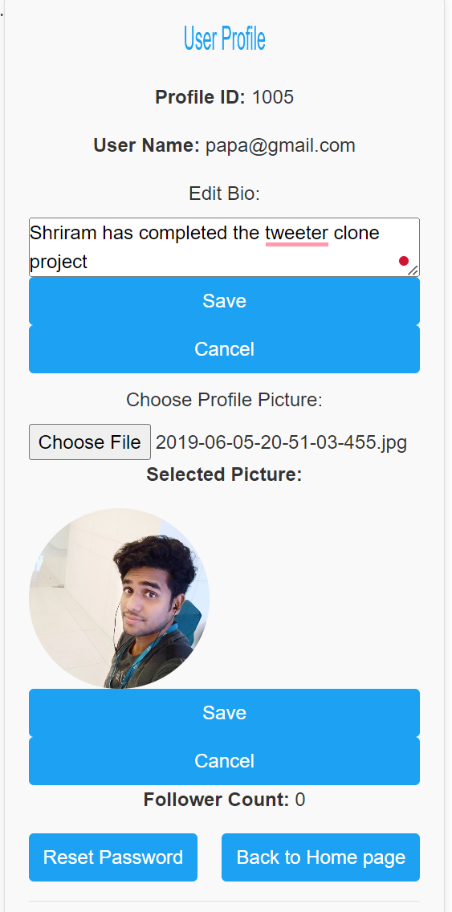

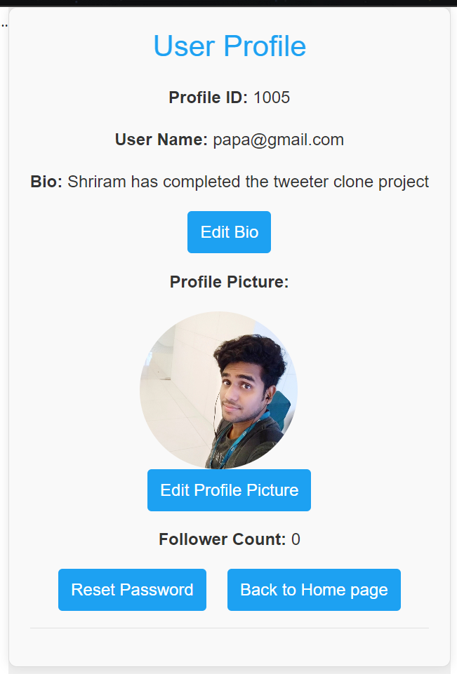

Reset password:

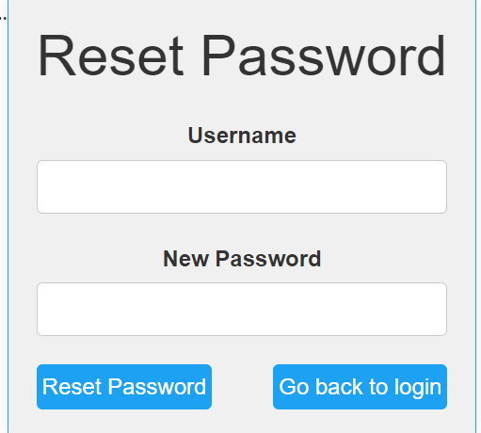

Following up people:

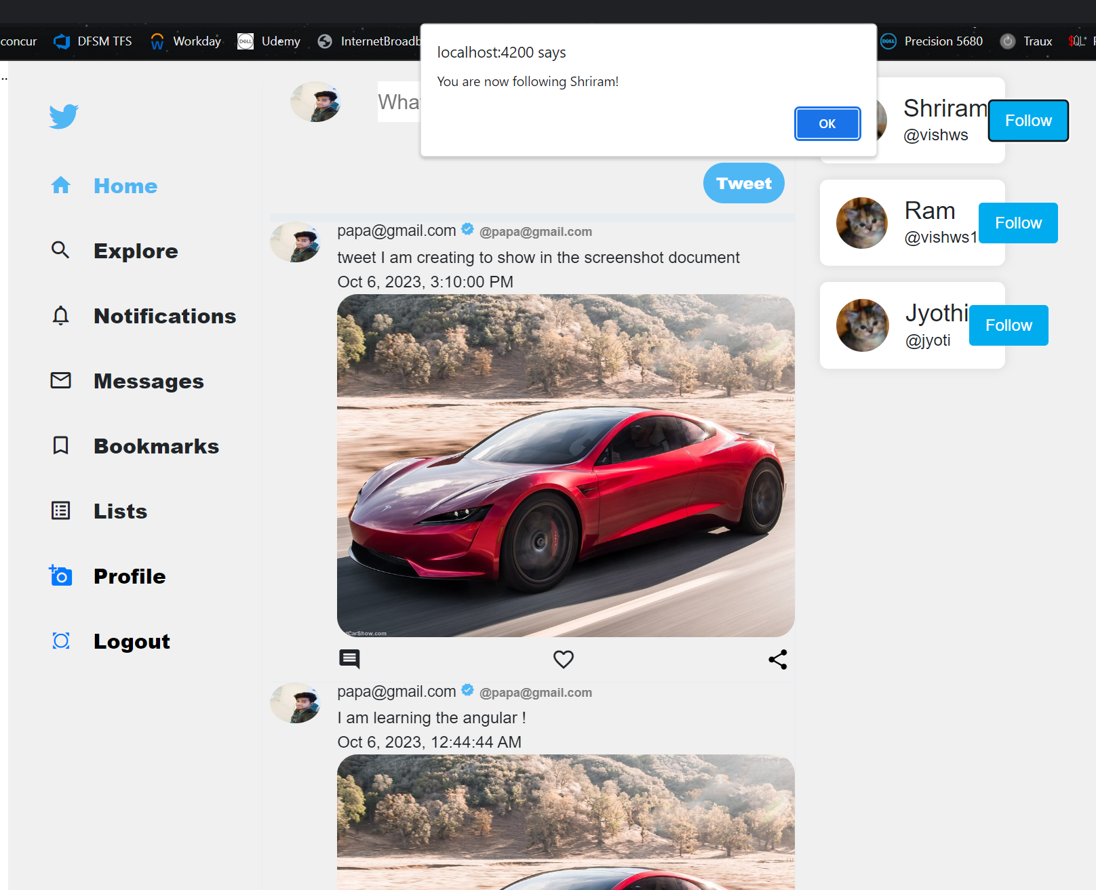

Putting some validation on already followed people

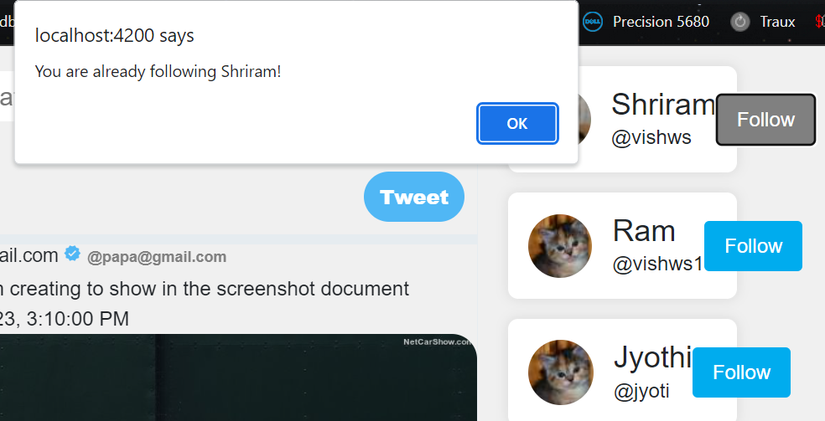

Commenting a tweet, liking it and sharing , accordingly colors will be changes on tweet

Like: color changed to red and got the alert

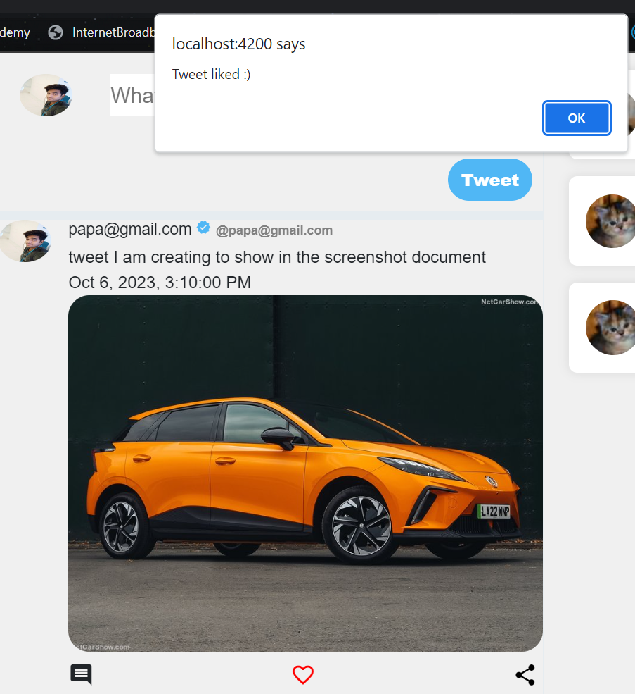



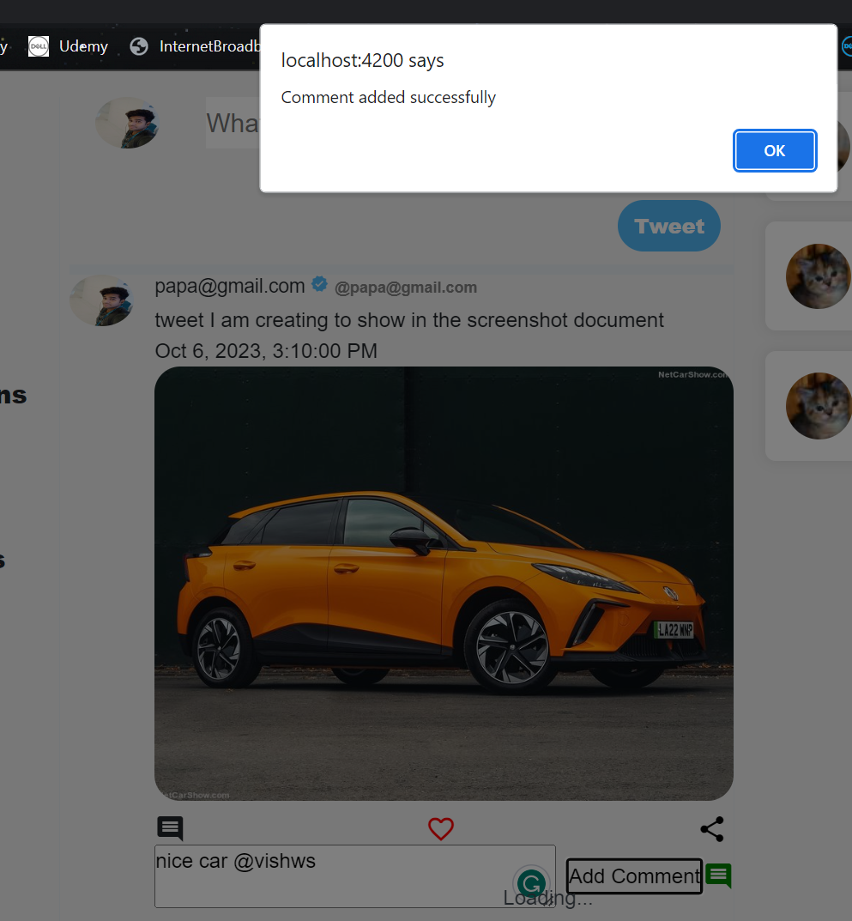

When you hit share icon and share the tweet

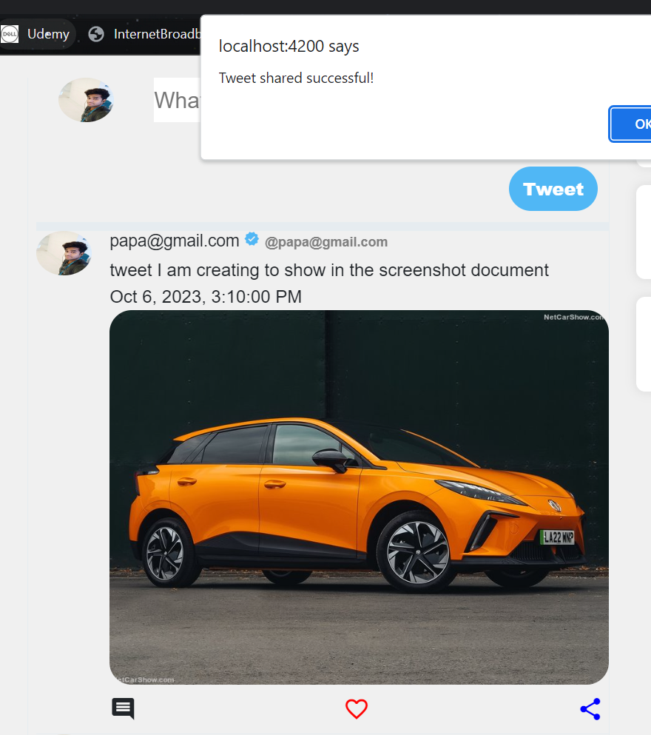

Finally once you logout, note- once you logout you cannot hit back arrow button in the browser, if hit it will lead to login page only

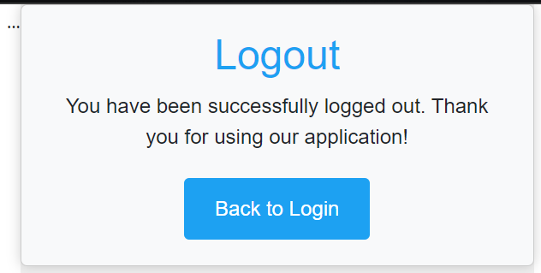

All below API have been integrated through either components or services in this project and embedded and working correctly on the project as shown in the each page working mechanism

